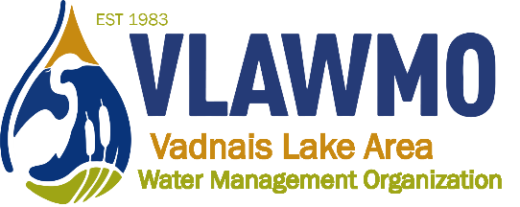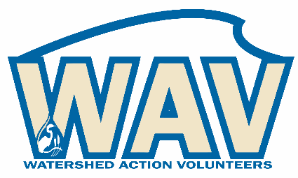
Watershed Action Volunteers
April 11, 2024
5:00-6:30 pm

Caribou Coffee
1080 Hwy 96 E – White Bear Lake, MN 55127

Agenda:
1. Introductions

2. 2024 opportunities
- Watershed mgmt plan update (10 mins)
- Website review discussion (pt 2) (20 mins)
- Tours, Adopt-a-Raingarden, macroinvertebrates, AIS, other
- Local leader/BMP consultation training

5. Closing questions and discussion

