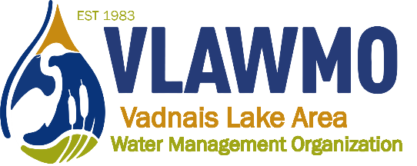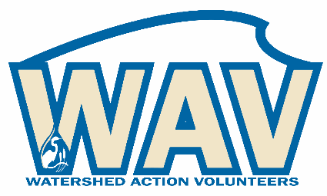
Watershed Action Volunteers
November 15th, 2022
6:00-7:30 pm
Minutes

Draft agenda:
1. Introductions
Present: Ceci Shapland, Ed Shapland, Susan Miller

2. 2022 Highlights
Nick provided a powerpoint slideshow conveying this year’s WAV highlight projects.

3. Clarifying ecological restoration: Opportunities and barriers
Nick introduced a discussion regarding ecological restoration and fieldwork as they relate to the WAV program. WAV is unable to offer these activities as events available to the broader public for two reasons:
- Liability policies and staff time limitations
- As a joint powers organization with its member cities and township, VLAWMO needs to prioritize and reflect activities that reflect the City plans, the VLAWMO watershed plan, and the education and outreach plan.

4. 2023 opportunities:
- Seed sowing workshop winter ‘23
  - Katherine has elected to facilitate this activity.
- “Soil your undies” education activity (bury undies and compare decomposition, tell community about it and about soil health)
- Create a Halloween costume for a culvert
- Rainbarrel workshop (returns): Katherine has elected to facilitate this activity.
- Project tours: Mini-tour, bike tour(s), series, etc. Possible scopes and things to help with:
  - Coordinate: One-stop tour or Newtrax bus tour
    - Newtrax: refreshments, photos of past projects
  - Option to help with tour promo
  - On-site help/table – such as a table that was set-up for the WB Montessori tour in 2022
  - Survey and/or follow-up with guests
- Consultation chats – (mentoring with L2L combo)
  - Ed and Ceci expressed an interest in doing consultation chats with folks interested in doing a cost-share project.
- Others?
  - Trash pick-up: Vadnais/Sucker Park
    - Ceci and Ed elected to lead this in April/May, 2023.
  - Smart Salting door hangers of interest, potentially divided up into different neighborhoods.
  - Boothing events: Waffle Breakfast, Heritage Days.
    - Kids games were advocated for. Fishing game, kids, etc.
    - Interest in kids giveaways for booths.
  - City Council guest presentation
    - City council presentation: Smart Salting, Turf Maintenance best practices promo, promo of new programs in VLAWMO such as groundwater/smart irrigation grants.
    - Option to support and join with the Stop Over Salting (SOS) campaign.

4. Collaboration efforts:
MN Master Naturalists: Tours, project kick-off at Westfield Park, possible other project kick-off events.
White Bear Lake Rotary and Birch Lake Elementary
Tamarack Nature Center: WHEP year 2, December 11th opportunity to share the WHEP results at the Tamarack Nature Center volunteer banquet.
PAI: Business/WB Parkway event, possible new raingarden.

5. CAC advising:
Feedback opportunities:
- WAV webpage
- VLAWMO webpage renovation
- VLAWMO operations
- Clean-up day and buckthorn removals of interest. Nick will investigate conducting ecological restoration as an internal WAV activity complete with waivers instead of to the broader public.

