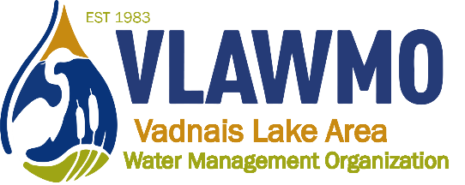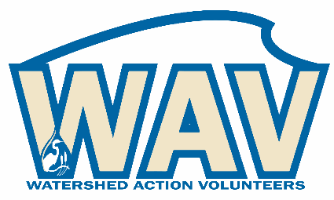
Watershed Action Volunteers
March 17th, 2022
6:00-7:30 pm
Meeting Minutes

Draft agenda:
1. Introductions
2. Good Neighbor Guide
- Team of editors and collaborators
- Identify specialty sections. Those who expressed interest to participate include:
  - Jeff Voss
  - Lilah Amon
  - Jackie Bussjager
  - Stefan Bruvelis
  - Ceci and Ed Shapland
  - Quiz idea/ self assessment and inquiry. Survey Monkey, Google forms, other quiz platforms?
  - Nick will send powerpoint and drafts to everyone to prep for next meeting.
  - Next meeting: Poll incoming for April/May
3. 2022 opportunities:
- WAV Activities and Sign-up Sheet – Google sheets access
Link to spreadsheet
New column for “training” option is now included. This is a way to involved while easing into leadership roles and working at your own pace. Come with what water experience and knowledge you have and we’ll go from there!
4. Collaboration efforts:
- Teal Pond at Tamarack Nature Center
    - Pilot WHEP program (Wetland Health Evaluation Program)
Individuals who expressed interest:
      - Lilah – send a volunteer application lilah.amon06@gmail.com
      - Gloria – Kansas City in May
      - Jackie
      - Ceci and Ed
      - Kyra Oliver
      - Nick will send everyone packets from Dakota County’s training materials to jump-start the in-person trainings VLAWMO and TNC will host in early summer. Dates TBD. Prospective Dakota County training date for wetland vegetation: June 30th, location TBD. Wetland vegetation will consist of Dakota County training + a VLAWMO/TNC led one, choose one or attend both. Macroinvertebrates will be online materials and VLAWMO/TNC-led training also in early summer/June.
- Bridgewood raingarden in Vadnais Heights
    - Communications and activity campaign
    - CAC input opportunity, Master Gardeners partnership, new adopt-a-raingarden site, City communications connecting Bridgewood raingarden to large-scale watershed efforts
      - Jackie and Gloria
      - Nick will integrate Jackie and Gloria with the communications with the Master Gardners, Beth Fritcher.
- Raingarden maintenance and tours: 3-part series with Rice Creek and Ramsey Washington watersheds
    - June 9th: Lake Josephine
      - Jeff Voss to attend
    - July 21st: Lakeaires Elementary
      - Gloria Tessier
    - Sept 22nd: WBL neighborhood curb-cuts

5. CAC advising opportunities:
Feedback potentials:
- WAV webpage feedback, ideas and organization. Is it useful, clear, and efficient? Is it welcoming and motivating?
- VLAWMO website update: Review period in 2nd half of 2022, goal to be live in 2023.
- VLAWMO operations, meetings, etc. What’s confusing, what do you think the public wants to know to be able to be more familiar and comfortable with VLAWMO’s operations?
- WAV shirts?

