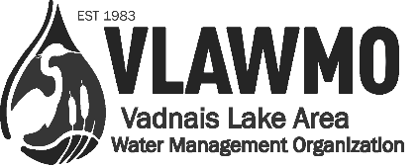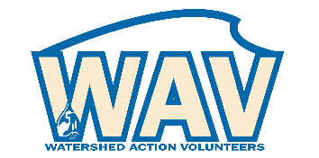
Watershed Action Volunteer Application 2022
For coordinated volunteer roles with the Vadnais Lake Area Water Management Organization (VLAWMO), please tell us about yourself, your interests, your skills, and the role that you’d like to fulfill.
The information on this form will be kept confidential and will help us find the most satisfying and appropriate volunteer opportunity for you. Thank you for your interest in supporting water resources.

Name: _______________________________________________________________________________
Address: ______________________________________________City: ___________________________
State:_ _______ Zip: __________ Phone: ___________________________________________________
Email: School/Employer:
1. Select volunteer area of focus desired:
See complimentary volunteer positions form at vlwmo.org/get-involved

___ Minnesota Water Steward (explore role in 2022 - next sponsorship opportunity 2023)
___ Citizen Advisory Committee (CAC): Network and plan with VLAWMO education/outreach staff
___ Adopt-a-Raingarden: Help maintain public raingardens solo or with a group
___ Aquatic Invasive Species (AIS) Detector: Receive training and tools to help detect AIS infestations
___ Invasive Species Control & Habitat Improvement: Join the fieldwork crew for select work days
___ Remote camera photo gallery: Network and set-up VLAMWO’s wildlife photo gallery at libraries, etc.
___ Watershed Culture Crafter: Demonstration photos lawn care/smart salting/pet waste/ adopt a drain
___ Leaf Pack Water Monitoring: Monitor macroinvertebrates at select sites solo or with a group
___ Project Photographer: Photograph key sites in the watershed at key times (rain, sunset, etc.)
___ Phenology: Participate in VLAWMO’s lakeshore picture posts for documenting changes over time

2. Background:

Past volunteer experience:

What talents or skills do you bring that you feel would benefit our organization?

3. Customizations and special needs:
In the open space below, describe how your desired position can be customized to meet your needs and interests. VLAWMO will work with you to outline a meaningful, practical volunteer experience.
What position customizations are needed to support you for a successful service project?

Do you have any special needs or existing obligations you’d like VLAWMO to know about?

4. Availability:
Please indicate days you’re most available (circle or highlight): Mon Tues Wed Thur Fri Sat
Month (start/end):
Year(s):
Times available: From ______ to _________ Any physical limitations? _____________________
Annual hours willing to dedicate to volunteer role: _________________________

5. Reference and agreement:
Reference name and number: ____________________________________________________________________________________
In case of emergency contact: ______________________ Phone: _______________________________
As a volunteer I agree to abide by the guidelines and recommendations from VLAWMO staff when engaging with the public. I understand that I will be volunteering at my own risk and that the VLAWMO, its employees and affiliates, cannot assume any responsibility for any liability for any accident, injury or health problem which may arise from any volunteer work I perform for the organization. I agree that all the work I do is on a volunteer basis and I am not eligible to receive any monetary payment or reward.

Signature: _______________________________________________________________________
Date: __________________________

