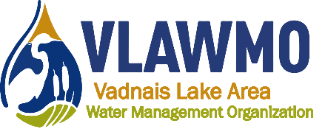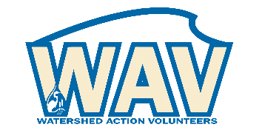

2025 Watershed Action Volunteer Application
Thank you for your interest in supporting our watershed! For coordinated volunteer roles with the Vadnais Lake Area Water Management Organization (VLAWMO), please tell us about yourself. Having a better sense of your background, skills, and the activities that most interest you as a volunteer helps us identify areas of involvement that will be a good fit.
The information on this form will be kept confidential and will be utilized to help staff find the most satisfying and appropriate volunteer opportunity for you.
Please email completed applications to angela.hugunin@vlawmo.org.

Name: _______________________________________________________________________________
Address: ______________________________________________City: ___________________________
State:_ _______ Zip: __________ Phone: ___________________________________________________
Email:___________________________________ School/Employer: ____________________________

1. Preferred Volunteer Focus Area

___ Education and Demonstration
Education campaigns, environmental behaviors demonstration, door hangers and similar outreach, workshop coordination, Local BMP Leaders (bee lawns, raingardens, etc.)

___ Partners and Collaboration
Project kick-off and open house events, local tours, tabling and dispersing education materials at public events, photo gallery display, special school and community group efforts

___ Fieldwork
Macroinvertebrate monitoring, aquatic invasive species (AIS) monitoring, adopt-a-raingarden, raingarden renovation, photography

___ Citizen Advisory or other
Advising and input on website, communications, and operations, etc.

2. Background

Please briefly describe any previous volunteer experiences:

What strengths or skills do you bring that you feel would benefit our organization?

3. Customizations and Accommodations
In the space below, please describe how your preferred focus area may be customizable for your needs and interests. VLAWMO will work with you to outline a meaningful, practical volunteer experience.
What position customizations are needed to support you for a successful volunteer experience?

Do you have any special accommodations you’d like VLAWMO to know about?

4. Availability
Please indicate days you’re most available (circle or highlight): Mon Tues Wed Thur Fri Sat
Month (start/end):
Year(s):
Times available: From ______ to _________
Any physical limitations? _____________________
Annual hours willing to dedicate to volunteer role: _________________________

5. Personal Reference
Name:_______________________ __________________Phone: ________________________________
Relation: _______________________________________

6. Emergency Contact
In case of emergency, contact: ______________________ Phone: _______________________________
Relation: _______________________________________

7. Volunteer Agreement
As a volunteer, I agree to abide by the guidelines and recommendations from VLAWMO staff when engaging with the public. I understand that I will be volunteering at my own risk and that VLAWMO, its employees and affiliates cannot assume any responsibility for any liability for any accident, injury or health problem which may arise from any volunteer work I perform for the organization. I agree that all the work I do is on a volunteer basis and I am not eligible to represent VLAWMO as an organization, nor receive any monetary payment or reward.

Signature: _______________________________________________________________________
Name (print or type): ________________________________________________________________
Date: __________________________

