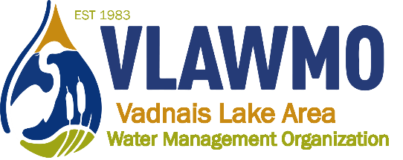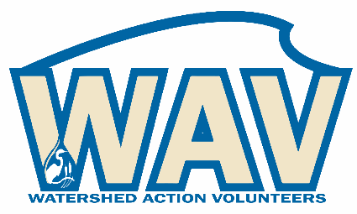

Watershed Action Volunteers
October 10th, 2023
6:00-7:30 pm
Vadnais Heights City Hall – Lakes Room
800 County Road E East

DRAFT Minutes

Agenda:
1. Introductions
Present: Ceci Shapland, Gina Schmidt

2. 2023 activity recap
- “Soil your Undies” education activity
- Birch Lake Elementary + Rotary Park partnership, special Rotary liaison for WAV identified
- VLAWMO 40-year anniversary series
- Tabling Heritage Days
- LeafPack support in North Oaks
- Winter seed sowing workshop
- Westfield Park kick-off event (MN Master Gardeners)
- Trash pick-up
- Adopt-a-Raingarden: 5
- AIS monitoring
- Macroinvertebrates Leaf Packs: Ceci, Ed, Erika
- Neighborhood tours
- L2L + consultation chats
- 2023 game plan spreadsheet review

3. Website renovation: Preview and direction
Feedback includes:
  - To strive for an emphasis on it being for “them” (the viewer/resident). A citizen can create an impact.
  - Switch the phrase “enhance” to “improve” in the “what we do” page
  - In tabs sets, clarify what’s a hyper link and what’s opening up to a category. Clarify expectations upon first viewing page as it loads up.
  - Switch “Am I in VLAWMO” to something like “Am I in the Watershed?”
  - Maintain a “spark” – a compelling reason to participate, such as “do you care about clean water?”
  - An interest to have a rolling slideshow on the homepage banner.
  - Interest to collaborate on City website links to VLAWMO. Possibility to reframe the link as “Water Resource Education”, and to have it be more visible under the search bar, particularly if there’s open space (rather than need to scroll through a large search bar). Emphasize quality, beauty, and stewardship of land to create a soft entry to a watershed focus and its logistics.

4. 2024 volunteer hopes and dreams
a) Consultation chats, project guide development, L2L coaching training, “cost share coaching”. This is identified as a top priority for 2024 is to emulate the Lawns to Legumes (L2L) training program on a more local level, covering the array of projects covered in the VLAWMO landscape and soil health grant programs. Goals include:
    - Spring: planning the training with leader volunteers
    - Host training: “train the trainer” – March/April
    - Maintain new leaders: create a tie in, space to identify with water resources and local place. Meet and network with other watershed leaders (MN Water Stewards, volunteers, etc.)
    - Format options: Consider a formal workshop, casual meet and greet, coffee talk, online, series of meetings/presentations, etc.
    - Key contacts: Ceci, Ed, Gina
b) Workshops and leadership opportunities
WAV will consider potential future custom activities including: PAI partnership, seed sowing winter workshop, and continuing neighborhood project tours for 2024.
c) Purple loosestrife beetles
There is an interest to continue to expand loosestrife beetle populations to new wetlands in order to help knock back invasive purple loosestrife.
d) AIS monitoring
New volunteer Tom interested in joining AIS monitoring for 2024.
e) Trash pick-up?
Change name to “Earth Day clean-up” consensus for 2024 is to tag along with City, org. or the VH Green Team. Aspire to expand connections and partnership opportunities with other local groups such as Birch Lake Improvement District, White Bear Rotary, North Oaks Garden Club, etc. Events and service projects ideally become integrated under both org umbrellas, supporting cross pollination between groups. Volunteer leaders to drive these connections and develop opportunities for service projects, tours, etc. VLAWMO staff assists and supports these connections as a collaborator for resources, technical tools, and assistance by request.
f) Tabling
Consensus is to maintain continued investment in tabling for public events, new events and opportunities are available. Continued training for volunteers to practice and get comfortable being in this representative outreach role.

5. Citizen advisory
Questions, idea generation, brainstorm

None

6. Closing questions and discussion

