Watershed Action Volunteer Application 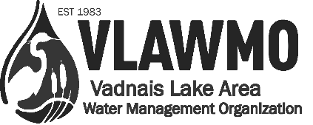
For coordinated volunteer roles with the Vadnais Lake Area Water Management Organization (VLAWMO), please tell us about yourself, your interests, your skills, and the role that you’d like to fulfill.
The information on this form will be kept confidential and will help us find the most satisfying and appropriate volunteer opportunity for you. Thank you for your interest in our work in watershed management.

Name: ____________________________________________________________________
Address: ______________________________________________ City:__________________________
State:________ Zip:_____________ Phone: _____________________
Email: _________________________________ School/Employer: ______________________________
Position: ____________________________________________________________________________
What talents or skills you have that you feel would benefit our organization?
___________________________________________________________________________________
Interests: Please tell us in which areas you are interested in volunteering. See supplemental “WAV” form for position descriptions. In the open space to the right, describe why this position is of interest and what you hope to gain from the position.
___ Citizen Advisory Commission (CAC) organizer Why is this position of interest to you?
___ Raingarden Chamberlain
___ Watershed Yard Care Promoter
___ Watershed Photographer
___ Watershed Storyteller
___ Neighborhood Event Planner
___ Aquatic Invasive Species (AIS) Detector

Please indicate days available: Mon Tues Wed Thur Fri Sat
Times available: From _____________ to _______________ Any physical limitations? __________________
In case of emergency contact: _______________________________
As a volunteer I agree to abide by the guidelines and recommendations from VLAWMO staff when engaging with the public. I understand that I will be volunteering at my own risk and that the VLAWMO, its employees and affiliates, cannot assume any responsibility for any liability for any accident, injury or health problem which may arise from any volunteer work I perform for the organization. I agree that all the work I do is on a volunteer basis and I am not eligible to receive any monetary payment or reward.
Signature: ________________________________________________ Date: _______________

