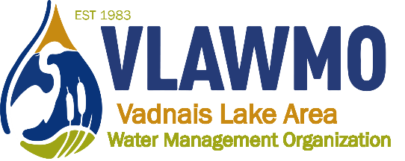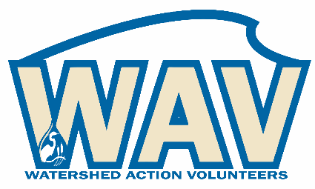
Watershed Action Volunteers
April 11, 2024
5:00-6:30 pm
Caribou Coffee
1080 Hwy 96 E – White Bear Lake, MN 55127
Meeting minutes
Agenda and minutes:
1. Introductions
Present: Ceci and Ed Shapland, Nick Voss

2. 2024 opportunities
- Watershed mgmt plan update (10 mins)
  - Nick provided updates and a description of the latest on the Watershed Management Plan. Results from the public survey will be presented on April 24th, 2024.
- Website review discussion (pt 2) (20 mins)
  - Nick provided a visual tour of the new website, all discussed the uses and various options for presentability to the public.
- Tours, Adopt-a-Raingarden, macroinvertebrates, AIS, other\
  - Macroinvertebrate monitoring covered at Oakmede and County Road F by Ceci and Ed, other sites are available for other volunteers.
  - It was determined that Nick would conduct a Doodle Poll to gauge the best options for when tour host sites would be available this summer. It was determined that this year’s tours schedule will be structured as:
    - One shoreline restoration tour (2 sites)
      - Possibilities discussed: Joe Coyne and Conrad Nguyen. Target June.
    - One neighborhood tour (3 sites)
      - Possibility for tour sites: Gina Schmidt, Karen Suzukamo, Janelle Green. Target July.
    - One native plant focused tour at Sucker Channel
      - Natural Shores Technologies to present. Target August.
  - Nick provided an update on the AIS program, there are 2 new AIS volunteers this year helping to monitoring potential new infestations in North Oaks.
  - A trash pick-up event was slated for May 4th at Vadnais-Sucker Regional Park. Event will be based out of the County Road F entrance (north entrance to the Vadnais trailhead).
  - Ceci and Ed will assist with the public booth at Vadnais Heights Heritage Days Kid’s Day on August 10, 2024. Other volunteers are encouraged to assist with set-up, presentation, and/or take-down. Event typically occurs late morning to early afternoon, VLAWMO provides booth materials, prizes, and educational game activities.

- Local leader/BMP consultation training
  - All discussed the scope and goals for next week’s training.

3. Closing questions and discussion
None

