Dear Neighbor,
Tired of staying home? Want to get involved and contribute in a safe, socially distancing activity that will improve the environment?
During this time, many of us have enjoyed walking, fishing and being outdoors, savoring the beauty of nature. We are so lucky to have so many beautiful places nearby.
The week of May 25 to May 30, the Vadnais Lake Area Water Management Organization’s (VLAWMO) volunteer group is coordinating an independent trash pick-up effort in Vadnais/Sucker Lake Park. We invite you to participate at your comfort and in accordance to social distancing. Please bring your own equipment such as trash bags, gloves and/or safety vests if available. The Trash Pick-up will be the whole week so people can participate at their convenience and stay safe distances from each other. If space is tight and distancing is difficult, please use your judgment on walking around or returning at a later time.
Pick your time (low traffic times might be best). Using the attached map of trash hot spots, enjoy a few hours of activity in nature. Map key: Circles on maps indicate trash pick-up spots and the stars are where to deposit your trash bag. Leave trash bags next to waste receptacles. Park staff will come by to pick them up.
Many thanks for helping to keep the area clean!
Sincerely,
Watershed Action Volunteers (vlawmo.org/get-involved)

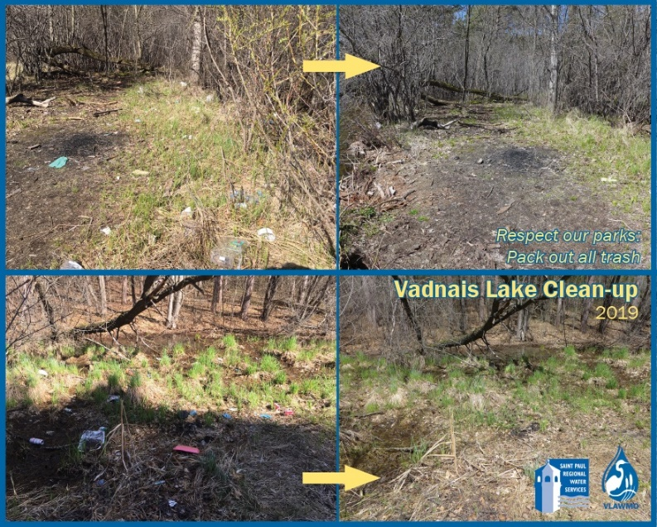

It would be great to have before and after pictures of your hard work! Please send to WAV@VLAWMO.org.

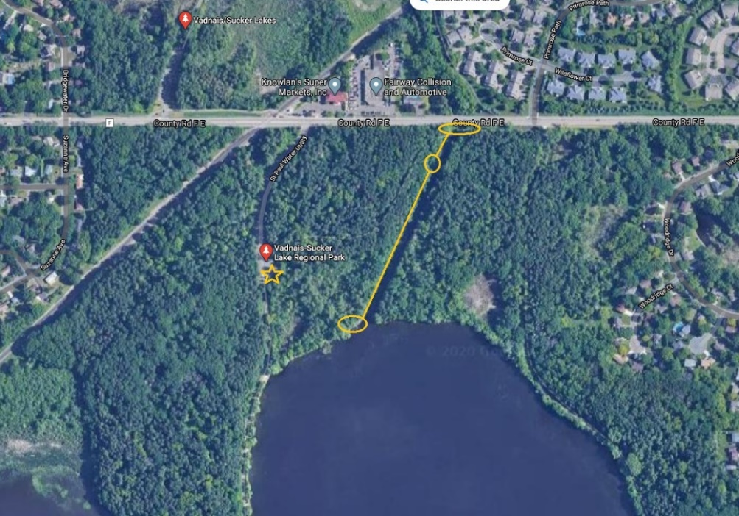
East Lake Vadnais Trash Hot Spots and Drop Off

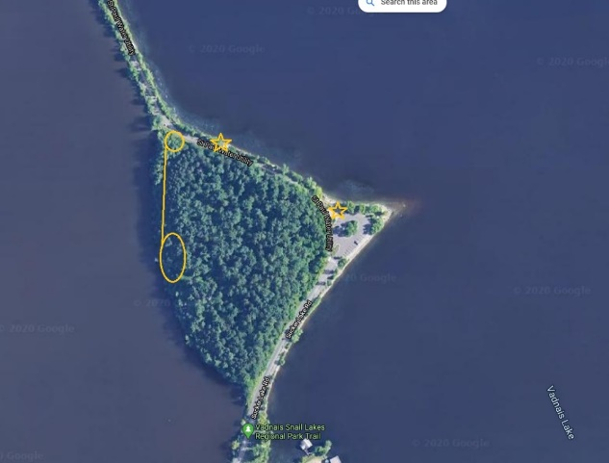

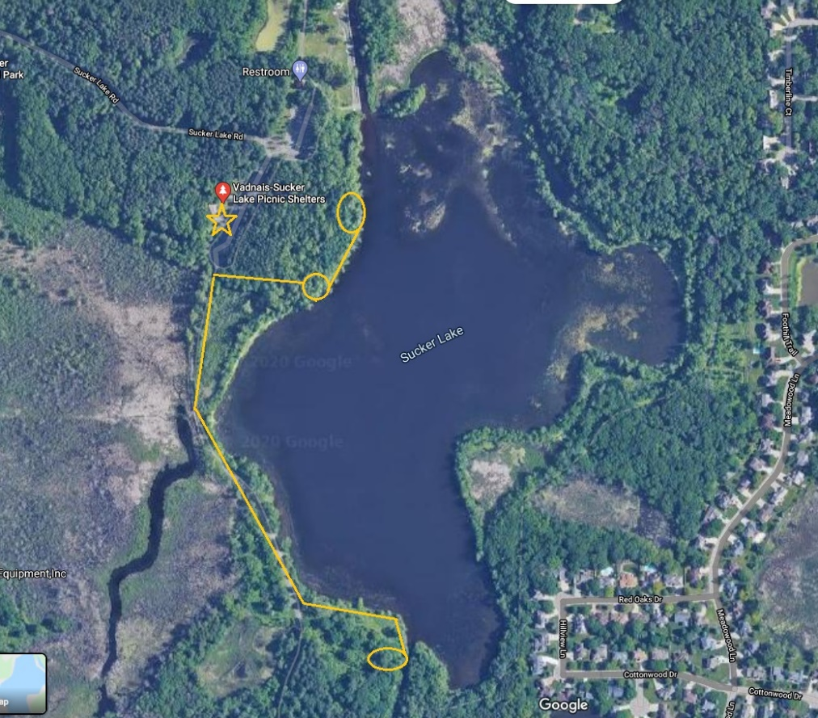
Sucker Creek Trash Hot Spot and Drop Off

