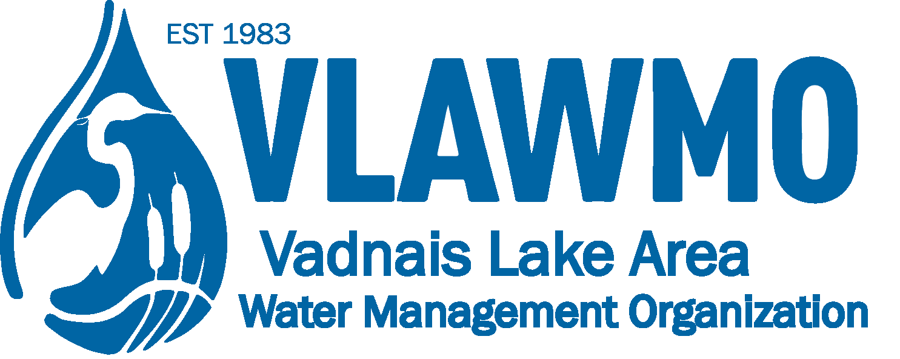

Watershed Partner Award Nomination

Nominee name and affiliation: Volunteer, resident, congregation, home/lake owner’s association, community group/club, etc.

Project: Ex. “BMP installation, business partnership event, volunteer recruitment event.” Include the goals of the effort, location, and nearby waterbody if applicable.

Hours and time duration: Start of project to end of project (mo/yr), estimate of hours dedicated to effort (prep, implementation, meetings, etc.)

Description of watershed impact: What was the result for water quality (education message portrayed, event attendance numbers, gallons of water infiltrated, lbs of road salt reduced, acres of turf converted, innovative project construction and specs, grant completion, unique partnership description, etc.)

Quote or summary statement: Based on the memory or experience of the effort, what’s the “take-home” summary that the community should hear about this individual/team and their effort? Are there any additional notable skills, dedication, attention to detail, or creative applications?

