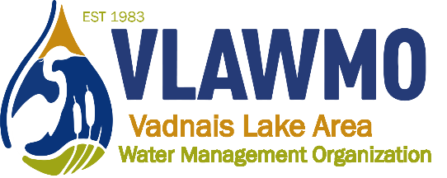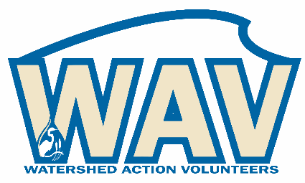
VLAWMO Citizen Advisory Committee (CAC)
Meeting Minutes
Vadnais Heights City Hall
3/6/2019 – 6:30 pm

Attendance:
Tom Falk
Rika Pennington
Ed Shapland

1. Review and comment on 2018 reports
- 2018 Annual Report
CAC comment: All indicated that the report is great information, but is unlikely to be read widely due to its length.

- 2018 Annual Report Summary
CAC comment: Ed commented that the stream on the history portion looks like it indicates ups and downs in VLAWMO’s progress. Arrows would help indicate that it’s a timeline with the visual of a moving stream.

Tom commented that he’s pleased with the Whitaker Treatment wetlands and encouraged VLAWMO to provide more info and more resources on this project. Reducing the size of a photo in this case would allow more text to describe it, in this case it was thought worthy of adding more text.

- 2018 Water Monitoring Report Summary
Tom commented that a future monitoring report summary should convey the path of Lambert Creek, conveying wetlands as a filter and showing data along the route of the watershed.

2. Learn about upcoming projects and provide feedback to VLAWMO's approach
- Birch Lake 4th and Otter
All commented that VLAWMO should get as much mileage as they can in the paper for this project.
- Goose Lake Spent Lime
No comments to report
- Adopt-a-drain
All commented at adopting drains often happens, but people don’t want to report and log onto a website as an extra step in the process.

All commented that signs are a good idea for acknowledgment, whether for an adopted drain or an adopted raingarden.

- Lambert Lake
Tom commented that the creation of Lambert Lake has had a noticeable impact on high flows in the creek.

3. Learn about VLAWMO's volunteer program options and provide comment on its effectiveness and efficiency.
Rika commented that to encourage growth in youth participation, VLAWMO should contact high school and middle school’s student councils and mentor programs. Tell them about the opportunity for service projects to support their goal of being responsible students.

Chippewa is also a participant in the science olimpiad, which connects to water quality information.

Rika commented that cost share participants could have help in explaining their project to family and neighbors.

Ed commented that VLAWMO should consider sending out a letter to every household in the watershed. A separate piece of paper to accompany water bills would be helpful as well.

Rika commented that VLAWMO having its own event opposed to joining other community events would be helpful to boost focus on water quality. Lots of well owners are also unsure as to where to go for information and testing.

Rika commented on a library that has a seed swap – perhaps native plants could be included.

Ed recommended online stormwater games for kids.

Tom acknowledged the predicament that having fairly good water quality and lakes means that public interest is low – when there’s a direct, urgent issue, interest gets high.

4. Member input: U of M Lake workshop, share and discussion
Rika and Ed attended a lake workshop at the U of M on February 21st.
Rika was impressed by remote sensing lake monitoring, the ability to check on data remotely and have it constantly visible online. She mentioned that this could be an outreach tool in that people have a habit of checking their phones for weather, perhaps also for water.
Ed mentioned the Lake Browser website, which measures clarity, CDOM, and chlorophyll state wide and displays it on a map. Volunteers collect clarity data, use satellite data as a baseline. Ed was also impressed at the information they presented on lakes – that lakes have temperature profiles based on season, wind, dimensions of the lake, and water coming in and leaving the lake. Each lake is truly its own unique system. Water mixes as seasonal turnover happens, and shallow lakes mix more due to not having the depth to have a contrast in temperature gradients.
Rika reported that lake management organizations do a lot with phosphorus management. Alum treatment, studying inflows and surface runoff are common. New techniques include temporary drawdowns of water levels to dredge and clean out sediment that’s high in nutrients or contaminated. Carp management is also an option to reduce nutrients in the water column, because carp are bottom feeders that continually stir up the sediment and what’s within it.

