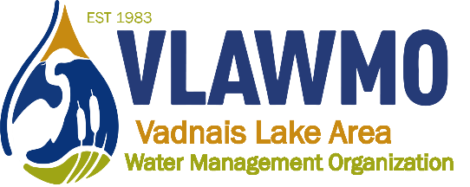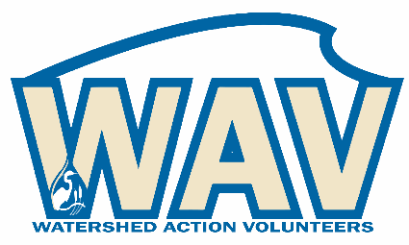

Watershed Action Volunteers
March 17th, 2021
5:30-7pm
Online meeting:
Join Zoom Meeting: https://us02web.zoom.us/j/83426870822
Meeting ID: 834 2687 0822 One tap mobile +13126266799, 83426870822# US (Chicago)

Agenda:
1. Introductions

2. Minnesota Water Stewards Capstone Projects
Project potentials
Graduated Steward team-up and assistance

3. 2021 Programs:
Preview of White Bear Center for the Arts programming
Continued from 2020: Rainbarrel, Jr Watershed Explorer
2021 standard and feasible programs:
Native plant swap, neighborhood tour, Jr Watershed Explorer, fieldwork volunteer days, Leaf Pack macroinvertebrates, picture posts
2021 wish list:
Public and school raingarden brush-ups, AIS detection, Birch Lake sand-iron filter, Adopt-a-Drain promo in East Goose subwatershed, MS4 strategies (salt, pet waste, illicit discharge, adopt-a-drain, BMP’s), and watershed “culture crafter”/demonstration of water-friendly behaviors

4. Other ideas, recap, and questions

5. Advising:
Feedback for WAV webpage, documents, VLAWMO operations, and Nick

Meeting Minutes:
Introductions:
“If you want to go fast, travel alone. If you want to go far, travel together.”
–African Proverb

MN Water Stewards Capstone Projects:
Capstone projects are in their planning phases, consulting with community partners to pinpoint project potentials and scope. As of this meeting date, the current options include:
Sierra: North Oaks options
  - Mary Hill bio-swale: Renovation, education
  - Hockey rink basin install: Design potentials, materials hauling, volunteer/labor recruitment, education
  - Mystery basin renovation: Design potentials, materials hauling, volunteer/labor recruitment, education
Gary: White Bear Lake/WB Schools
County Road F raingardens, school raingardens, programming and education connecting homeowners (curb-cuts) and residents (schools: Lakeaires, VH Elementary, Central Middle) to maintenance and familiarity of green infrastructure. Connection to East Goose Lake efforts.
2020 carry-overs:
Projects that started in 2020 and are being carried over into 2021.
- Rainbarrel program: Leftover rainbarrels from 2020 to giveaway, online workshop presentation in May/June, demo install (guest invite – Gloria volunteers).
- Jr Watershed Explorer booklet – Put survey back online, gather more feedback before adding new segments to the booklet. Connect with North oaks homeschool network, enlist a team to help promote:
  - School newsletters/parent-teacher networks
  - Scout troops, cub scouts
  - Library flyer/other locations flyers
  - VLAWMO social media
  - Nextdoor.com outreach

2021 standard and feasible programs:
Planning projects that have been done in previous years and projects that are feasible for 2021 efforts:

- Native plant swap – Ed and Ceci. Jumping worms transferring?
Inclusion of seedlings and giving away/sharing?
Check with DNR, Dawn
Possible sharing of knowledge – teach-in, training opp.
- Neighborhood tour: Meet at central location, 5-6 tour sites.
        - Planning ideas:
          - Follow on a caravan route, chat social distance on site. Meet at start, middle and/or end?
          - Cover the basics on site selection: Raingarden, lawn, prairie, groundcover, etc.
          - Possibility to add public green infrastructure or watershed significant sites.
          - Map and interview in a packet, concise times outlined to meet and connect with homeowners.
          - Idea: volunteers there at certain sites to interpret?
          - Tickets, signage/indicators to mark tour sites, expand to public projects. Shorten timeframe.
          - Follow-up before June to plan – separate meeting June.
          - Loop in Gloria for planning.
          - Also an opportunity to promote the Jr Watershed Explorer book
- Fieldwork volunteer days
  - Possible weekend event leadership: Jackie, Susan, Ed, involving more families and younger people.
    - Plant ID, shoe brushes.
  - Ask Dawn about U students joining on a weekend?
- Leaf Pack macroinvertebrates
  - Gary as a possible leader – Oakmede, Whitaker Pond. Ceci and Ed at Kohler flume or Co Rd F, Susan on Deep and Charley channels.
  - Rock pack – order for 2021, implement in Pleasant and Deep channels
  - Homeschool connection at North Oaks – high school age
  - Picture posts:
- Tamarack post has a map error on website
  - Brush-up posts help: Susan, Gloria
  - Opportunities without a post? – East Goose Lake algae blooms
    - Susan to send link for new picture geotag method

2021 wish list:
Public and school raingarden brush-ups – update only, new volunteers welcome, potential Gary capstone project

AIS detection – update only, update only, new volunteers welcome

Birch Lake sand-iron filter – investigate BLID involvement? New volunteers welcome

Adopt-a-Drain promo in East Goose subwatershed – update only, potential Gary capstone project.

MS4 strategies (salt, pet waste, illicit discharge, adopt-a-drain, BMP’s), and watershed “culture crafter”/demonstration of water-friendly behaviors – Consult with Ceci

Trash pick-up events

