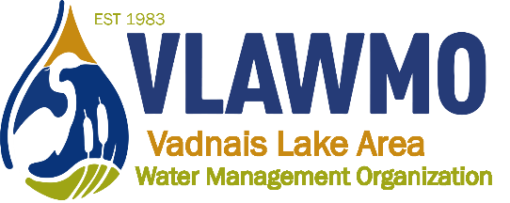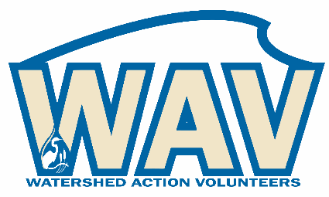

Watershed Action Volunteers
October 10th, 2023
6:00-7:30 pm
Vadnais Heights City Hall – Lakes Room
800 County Road E East

Agenda:
1. Introductions

2. 2023 Recap
- “Soil your Undies” education activity
- Birch Lake Elementary + Rotary Park partnership
- VLAWMO 40-year anniversary series
- LeafPack support in North Oaks
- Neighborhood tours
- L2L + consultation chats
- 2023 game plan spreadsheet

3. Website renovation: Preview and direction

4. 2024 volunteer hopes and dreams
a) Consultation chats, project guide development
b) Workshops and leadership opportunities
PAI partnership, seed sowing, tours and demos, others?
c) Purple loosestrife beetles

5. Citizen advisory
Questions, idea generation, brainstorm

6. Closing questions and discussion

