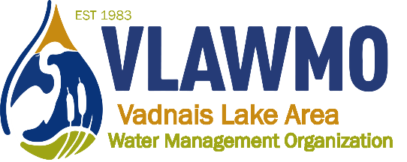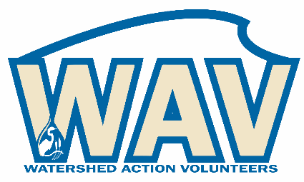
Watershed Action Volunteers
March 17th, 2022
6:00-7:30 pm
Meeting Memo

1. Introductions: Agenda only

2 Good Neighbor Guide

Who: Ceci and Ed Shapland, WAV members as desired
What: A Community-Blue grant supported booklet. Community Blue grant will contract a graphic designer to help develop the “guide”, which is a basic how-to regarding water-friendly yardcare and home practices.
When: Community Blue grant to be submitted April 13th in April TEC meeting. Booklet design occurs for the duration of the year, consisting of drafts, reviews, layout design, community editing, and then printing and distribution.
What WAV can do: Engage in draft review process with Ceci, Ed, and Nick, both before and after Community Blue grant submission. Help conduct “test runs” with drafts with neighbors. Drafts and editing process will be conducted primarily through email exchange and will have separate planning meetings, dates TBD. Reference a template: MWMO Good Neighbor Guide – WAV will adapt this to VLAWMO with more local connection and character.

3. 2022 Opportunities: Agenda and spreadsheet attachment

4. Collaboration Efforts
a. Teal Pond at Tamarack Nature Center

Who: WAV and Tamarack Nature Center Volunteers. Tamarack, County, and VLAWMO staff facilitating and supporting volunteers.
What: A pilot program modeled after WHEP: Wetland Health Evaluation Program, a program that’s been active as a volunteer wetland monitoring effort for over 20 years in Dakota County. Monitor aquatic macroinvertebrates at Teal Pond or monitor wetland vegetation (choose a “team”). Attend virtual and in-person trainings, conduct sampling activities in the summer, assist staff in compiling data, interpreting data, and developing the end-of-year report. Present report and summarize project at December, 2022 Tamarack Nature Center volunteer recognition event (outdoors, bonfires, coffee bar, etc. There will be a microphone and poster display potential.)
When: 1) Learn more at an early spring Teal Pond tour held by Ramsey County staff Justin Townsend: Date TBD. 1) Attend WHEP Dakota County trainings in May and June for aquatic invertebrates and wetland vegetation ID. Dates TBD
What WAV can do: Training and sampling, general restoration upkeep at Teal Pond, analyze data and develop report, present and describe project at Tamarack volunteer event. Help brainstorm how educational elements of this effort can integrate into public attention: Lead efforts to find speaking venues and share project insight paired with how the public benefits from healthy wetlands as well as what we all can do to help protect and improve wetlands (individual, collective, civic engagement).

b. Bridgewood raingarden in VH

Who: The Master Gardeners have approached WAV to find an educational volunteer effort. The new Bridgewood raingarden in Vadnais Heights was selected. Master Gardenders to host an info-session on the raingarden combined with a home gardening demo.
What: Maximizing education and interest on a new raingarden while its still newly installed.
When: May/June VLAWMO spring intro, depending on project construction (contracted). Master Gardeners event (July/Aug). Fall check-in and clean-up.
WHAT WAV can do: Help promote, attend May/June event w/ basic tabling support, conduct follow-up fall check-up maintenance, take photos of project throughout year. (Master Gardener event can be attended but not requested for WAV volunteers).

c. WB Montessori native plant tour

Who: Natural Shores Technologies, Inc, VLAWMO, WB Montessori. VLAWMO cost-share participants as volunteers.
What: Maximizing education and interest on a new raingarden while its still newly installed.
When: August 11th 7-8:30 pm at WB Montessori.
WHAT WAV can do: Be present and available on-site before and after the event to share your experience with your cost-share project. Have photos on-hand, take questions as they arise. Wear a WAV shirt or identification badge to signal availability for discussion.

d. North Oaks Bioswale
Who: North Oaks residents.
What: Maintain newly renovated North Oaks Bioswale, clean out entrance basins, document and share to the public.
When: Spring clean-up event, summer check-in, fall clean-up event.
WHAT WAV can do: Maintain Bioswale, clean out Bioswale inlet basins, assist with reviewing and commenting on seasonal maintenance guide.

e. Raingarden maintenance and tours

Who: MN Water Stewards, WAV, staff from Rice Creek, RWMWD, VLAWMO
What: 3-part series to tour and maintain raingarden BMPs. Networking between neighboring watersheds and their volunteer groups. Education opportunity on how raingardens work and how they’re maintained.
When: June 9th: Lake Josephine 6:30-8 pm
July 21st: Lakeaires Elementary 6:30-8 pm
Sept 22nd: WBL neighborhood curb-cuts 6-7:30 pm
WHAT WAV can do: Attend events with watershed staff, help promote to general public

5. CAC advising: Agenda only

