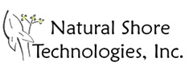

Restoration Proposal for:

Mr. Conrad Nguyen
1323 Hedman Way

Proposal Date: May 5th 2017

Prepared by:
Bill Bartodziej M.S., Senior Restoration Ecologist
Natural Shore Technologies, Inc.
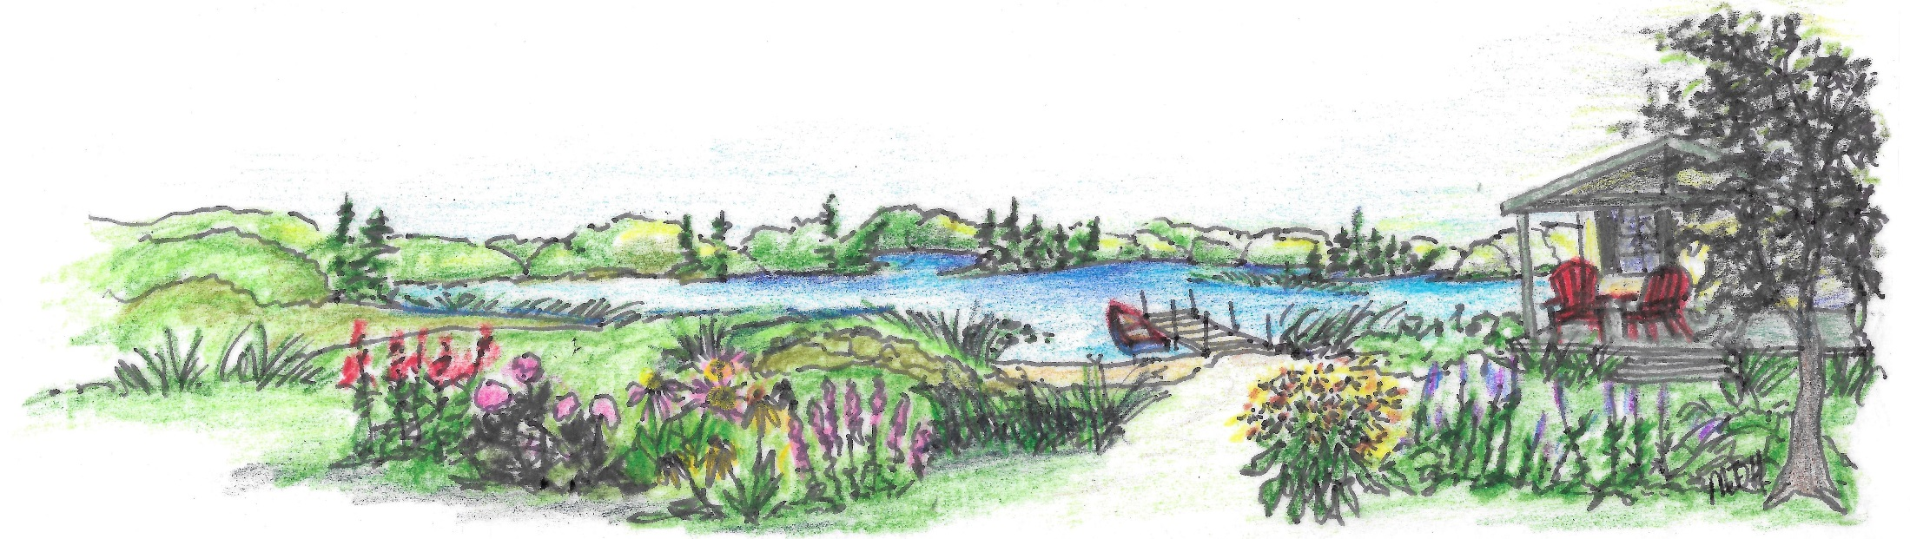
612.730.1542 bill.b@naturalshore.com
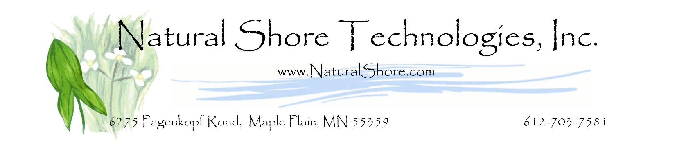

May 5th 2017

Dear Conrad:

Thank you again for giving Natural Shore Technologies the opportunity to bid on your project. Below is a Project Summary which outlines our restoration methods and cost breakdown. We would like to emphasize that we tailor our restoration approach to fit your site characteristics and specific objectives. We look forward to developing a partnership with you to produce an exceptional restoration that exceeds your expectations.

As we discussed, we recommend redirecting water flow away for the eroded slope. This will help with erosion control on your property. This work is not included in this bid.

We would enjoy the chance to answer any questions that you have regarding this restoration proposal. We take great pride in our reputation and attention to customer satisfaction. After you have read through and are comfortable with the proposed plan and specified cost, please sign the contract that is provided. A down payment and a signed contract are required to book your project.

Best regards,
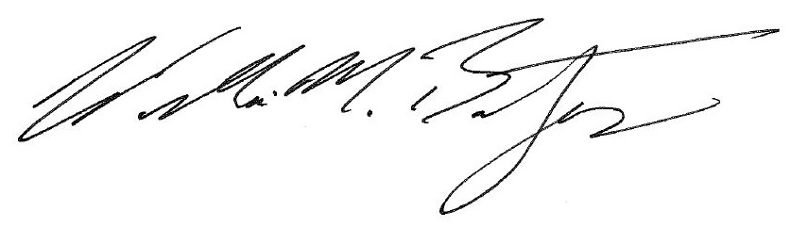
Bill Bartodziej, M.S., Natural Shore, Inc.
Project Summary
- Dimensions: 1,200 SF upland slope – restore to short grass prairie
- Site assessment and plan development include: detailed site preparation methods, plant selection, and a project timeline and work schedule for our staff. Because most of projects involve the establishment of natural buffers, site drawings and planting plans are not necessary. We have found that over time, native plants will seek out the optimal micro-habitats and flourish. However, project plan drawings can certainly be provide at an additional cost upon client request.
- Delineate and verify total restoration project area.
- Design planting so that flowering will occur at different periods throughout the growing season. Short prairie grass species will be used around the buffer edges closest to the turf.
- Kill all weedy species and turf with an herbicide appropriate for upland or aquatic use. A licensed herbicide applicator from Natural Shore Technologies will apply the treatment.
- Fill eroded slope area. Stake in wood fiber logs to slow water flow.
- Apply a 3” layer of shredded hardwood mulch over the entire project site.
- Lay out plants into plant zones per plan specifications. We will use 545 plants for your restoration.
- Install all plants @ approximately 1.5’ centers. Move mulch aside and a light mulch layer will be returned around the base of the plants to hold moisture. Mulch will not be placed below the normal water level.
- Site monitoring and maintenance (not included in this bid)

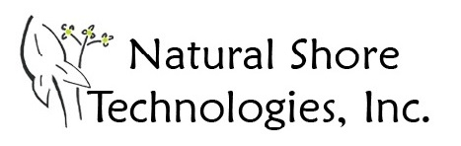

Nguyen Restoration Project

Project Cost

This bid includes project design and management, all materials, labor, and a two year maintenance plan. This is a comprehensive bid estimate and valid for thirty days. We require a 50% down payment to schedule your project.

Cost Breakdown

Site Design, Project Management, Mobilization, labor |  | $887.00
Site preparation, soil placement, herb. Trt |  | $610.00
Plants - 545 - 3" containers |  | $1,716.75
Erosion control materials - wood fiber logs |  | $40.00
 | TOTAL = | $3,253.75

Site maintenance (optional)

Site maintenance includes three visits per year during the growing season to monitor and conduct activities that will ensure proper restoration establishment. We use the most appropriate, up-to-date maintenance techniques such as targeted herbicide application, hand pulling, mowing, and spot weed whipping to effectively control invasive weeds.
Our lead maintenance supervisor has a B.S. in Biology and 10 years of field experience.

*Note we do offer long-term maintenance contracts. Over 90% of our clients use that service.

Nguyen Restoration Project
Staff Qualifications

Our company has over 50 years of combined ecological restoration experience. We are a local company that focuses on quality ecological restoration in the Metro area. Our clients vary from private estates on Lake Minnetonka, to large corporate headquarters in Eden Prairie. We also work with many city and county governments and watershed management organizations. We are fully insured.

Our specialty is lakeshore and wetland restoration. We have restored many miles of lakeshore in Minnesota, more than any other company. Please see our portfolio for examples of our restoration projects that include; shorelines, wetlands, prairies, savannas, and rain gardens.

Please see our project photo book at: http://www.blurb.com/books/6034090-natural-shore-technologies-inc-photobook

Natural Shore Technologies Plant Material

We have commercial and retail greenhouses in Maple Plain. Our plants are Minnesota native perennials that will flourish year after year. Utilizing our own plant material in our projects assure quality control. Our wetland and prairie plants are guaranteed to establish during the first growing season. Perennial plants put most of their energy into establishing root systems so please keep in mind that the first year of growth will be mainly underground. You will see some flowering the first year, but significantly more flowering during the second year of establishment.

Information about our retail native plant greenhouses located in Maple Plain is also available at: www.naturalshore.com

Nguyen Restoration Project
Guarantee

We stand by our native plant material and our ecological restoration services.

Native plants that we install are guaranteed to establish during the first growing season. Any plant material that does not make it through the first growing season will be replaced at no charge to the client.

On projects that we install and manage, we will guarantee successful establishment of your ecological restoration within three full growing seasons. This proposal provides a plan for accomplishing the restoration of the project site. If successful establishment does not occur within three growing seasons, all necessary steps will be taken to ensure the eventual success of the project, at no additional charge. For purposes of this guarantee, successful establishment is defined as follows: That the presence of at least 80% of the original seeded or planted species can be found on the site, and that the overall density of vegetation is comprised of no less than 80% native species.

The only exceptions to this guarantee have to do with plant death due to acts of God (floods or drought) the actions of others (vandalism), or animal herbivory (e.g., geese, muskrats). If these extreme circumstances do happen to occur, we will work with the client at a reduced rate to make all necessary repairs.

Our goal will always be to create successful, long-term partnerships with our clients. Our guarantee is the best in the business, and provides you with a clear understanding that we are here to fully support your ecological restoration endeavor.

Nguyen Restoration Project
Contract

A down payment of $1,626.88 is required to schedule your project.
The remainder of the project cost is due at project completion.

Please note that this proposal is valid for 30 days from the date on this Contract.

If you would like to proceed with the above outlined project, please sign the contract below.

Project Name: Nguyen Restoration Contract Value: $3,253.75

Client name: Conrad Nguyen

Signed: ________________________________________________________ Date _________________________

Contractor: Natural Shore Technologies, Inc.

Signed: Contract Date: Contract Date for 30 Day term

William M. Bartodziej, M.S.
Senior Restoration Ecologist, Natural Shore Technologies

Please return a signed copy of this contract and a check to: Natural Shore Technologies, Inc.
6275 Pagenkopf Rd.
Maple Plain, MN 55359

Nguyen Restoration Project

Benefits of our quality restoration work.


