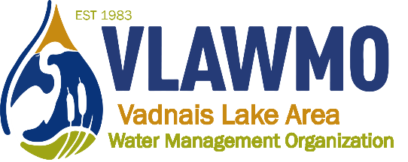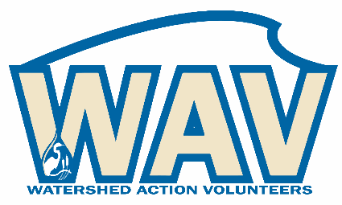
Watershed Action Volunteers
March 7th, 2023
6:00-7:30 pm
Online meeting:
Join Zoom Meeting: https://us02web.zoom.us/j/81169611007
Meeting ID: 811 6961 1007 One tap mobile +16469313860,,81169611007#

Blue highlights: Activities other volunteers can hop on to help, ask VLAWMO staff for more info and to get involved.

Agenda:
1. Introductions
Present: Ceci and Ed Shapland, Susan Miller, Nick Voss

2. 2023 opportunities
- “Soil your Undies” education activity
  - Bury undies at 1/2’ depth
  - 100% cotton
  - Start 1st or second week of April
  - Photos of before and after
  - Flag markers for marking the burial sites
  - May-July (60 days total)
  - 2 packs , 6-8 locations
  - Locations: WB Montessori (contact info to Ceci), VH wooded wetland, VH raingarden, sedge in Ed and Ceci’s yard, turf in VH park/Commons, Gem Lake Heritage Hall raingarden, Sharon Loraine cost-share prairie
  - Get write-up from Washington County, send contact info for Angie Hong to Ceci
  - Other volunteers can potentially join to add to the activity at new locations (yards, forest, gardens, wetland, shorelines, etc.) VLAWMO able to reimburse costs.
- Birch Lake Elementary + Rotary Park partnership
  - May 16, 17, 24, 25
  - Susan Miller penciled in for being the Drippy costume for student appearances after the educational portion. Others welcome to trade off for different times of day or different days.
- VLAWMO 40-year anniversary
  - Brainstorm idea: Sucker Channel celebration combination: Q & A, food, macroinvertabrates activity, tour of new sucker park restoration, 40-year history summary on hand for conversation starter
  - Mid to late August
  - Ramsey County pavilion rental
  - Discuss usage of park, assets, trash pick-up photos

- Neighborhood tours ideas
  - Two raingardens in WBL – Kehleher and Devries, St Mary’s of the Lake raingarden also nearby
  - Gina Schmidt
  - Katherine Doll Kanne/Angela Marlette neighbors
  - Sharron Loraine/Bev Hall neighbors
  - Conrad Nguyen, Birch Lake shoreline
  - Megan Sigmon-Olsen and Oakmede restoration at Lambert Creek
  - White Bear Montessori with Natural Shores (2nd annual, August)
  - Bike tour? Audience consideration, difficulty of road shoulder biking?
    - Note to be sensitive of folks’ garden being shown – maintain follow-up and consistency if they’re on the roster.
  - Bee lawns
    - WBL, Vadnais Heights locations
  - Question on whether there’s any L2L grant recipients in watershed? Check with Metro Blooms.
- L2L + consultation chats
  - Briefly discussed, Ceci engaging with this opportunity, more information provided by request.
- 2023 game plan spreadsheet
  - Briefly discussed, seems to be functional and accessible for volunteers to use.

3. Website renovation: Preview and direction
Nick to Email draft wire frame visuals for comment by request.

4. 2023 volunteer application forms
Nick to email 2023 volunteer application for comment by request.

5. Closing questions and discussion

