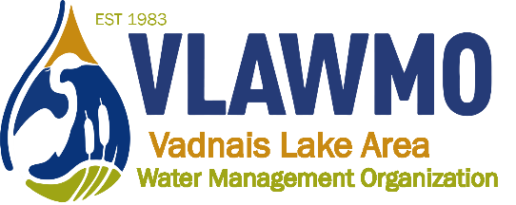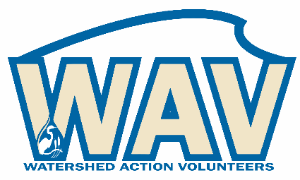
Watershed Action Volunteers
April 18, 2024
5:30-7:00 pm

Local BMP Leaders
Vadnais Heights City Hall – Lakes Room

Agenda:
1. Introductions

2. BMP consultation
- Mapping and technical project planning (topography, sun/shade, spacing, measurements, mark-up tools)
- Thinking like a landscaper: Aesthetics, preferences, and project construction strategies, and maintenance. Guest speaker Leo Schuch.

3. Communication:
a) Methods: Email, phone, in-person
b) Organization: How VLAWMO directs prospective grant applicants to
BMP leaders. Review draft contact spreadsheet (name, project type,
communication scope, time availability)
- Communication tips and confidence building – create your “elevator speech”

4. Wrap-up and discussion

