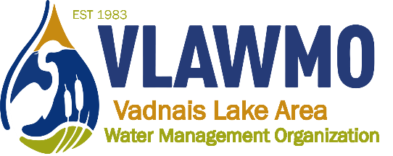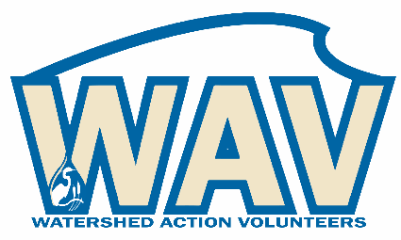

Watershed Action Volunteers
June 16th, 2021
6:30-8pm
Online meeting:
Join Zoom Meeting: https://us02web.zoom.us/j/83426870822
Meeting ID: 834 2687 0822 One tap mobile +13126266799, 83426870822# US (Chicago)

Agenda:
1. Citizen Advisory Committee (CAC) updates
Previously, the advisory component of the WAV has consisted of an end-of-year review. While this has been effective on a program level, it’s been challenging to maintain on a practical level. For example, it’s difficult to summarize and recollect the efforts from an entire year, and provide feedback and advise after the fact.

VLAWMO outreach program is starting a process of adding an additional emphasis on project communication. This project communication program uses a campaign-style approach, focusing on specific projects and efforts and organizing communications and outreach accordingly project customer audiences. Mirroring this shift, Citizen Advisory opportunities will be interspersed throughout the year and on the front end of communication campaigns. This is welcome to all WAV members as well as formal CAC volunteers. For example, VLAWMO staff may present high level concept plans and the Citizen advisory could then review these drafts and comment on things like identifying key stakeholders, how we approach and communicate with them, who else should be at the table, and what other local knowledge is pertinent that VLAWMO may have overlooked. Participation will be elicited in email, feedback and advisory is welcome in email or phone methods.

2. Fieldwork update
VLAWMO staff will hold occasional (2-3 times/yr) field events outside of Fieldwork days in conjunction with the U of M Community-engaged Learners program (Coordinated by staff member Dawn Tanner). Volunteers engaging in fieldwork outside of VLAWMO-sponsored events will be doing so independently under the Adopt-a-Raingarden program. The key difference is that volunteer activities without staff present will no longer be promoted to the public.

3. 2021 Programs:
Upstream: White Bear Center for the Arts
Starting June 29th, a series of 6-10 curated tea ceremonies will take place this summer as a part of a VLAWMO-sponsored education program. “Upstream” is funded by Community Blue, originally started in 2020 and postponed due to COVID-19. Watershed Action Volunteers are welcome and encouraged to attend one or more of these activities to speak on behalf of basic watershed concepts, basic VLAWMO programs and projects, and the history of the watershed. VLAWMO staff will prepare interested volunteers with a base of talking points to be ready for this activity.
Jr Watershed Explorer Booklet
Continued promotion locally
Neighborhood tour
Planning host sites, liability procedures, and DIY tour protocol for August, 2021. Separate meeting needed for in-depth planning.

Programs supported by staff-led training:
-Biggest need: Tabling at community events. Staff will attend community events such as WBL MarketFest with invitations for volunteers to join, learn, and experience the tabling process. Separate trainings for tabling will also take place to help develop skills and guidelines for representing VLAWMO to the public.

- Aquatic Invasive Species (AIS)

- LeafPack macroinvertebrates monitoring, Pop-up education macroinvertebates

- Macroinvertebrates education events: Vadnais Heights Playground summer program, North Oaks Homeschool, etc.

- Website review: Receive a website task and staff will observe how website is navigated and used. Review for future website updates and exploring new styles. Will take place in-person projecting the screen on a VH meeting room, as COVID/vaccinations allow.

Back burner/conduct as interest arises
      - Trash pick-up
        - Fall, 2021
      - Habitat improvements
        - Upcoming opportunity with supporting a new public raingarden at Berwood, Vadnais Heights. Interested volunteers will become familiar with “Adopt-A-Raingarden” PDF and procedure, help train and support parks commission on raingarden care.
      - Raingarden brush-up/buckthorn hand pulling
      - MS4 strategies (salt, pet waste, illicit discharge, adopt-a-drain, BMP’s)
        - Staff will create a specific map of key photo sites on the themes of pet waste and smart salting to support City MS4 programming.
      - “Good neighbor guide” – Fashioned after MWMO’s
      - Calendar: Watershed photos combined with a schedule for water-related phenology, garden and raingarden maintenance, VLAWMO meetings, local events and community happenings (I.e. WBL MarketFest, etc.) Fashioned after RWMWD.
      - Water conservation: Programs, incentives, and messaging in other cities: i.e. Maplewood

4. Volunteer networking: Enhancing connectivity and planning through a forum or group page.

5. Recap and questions

