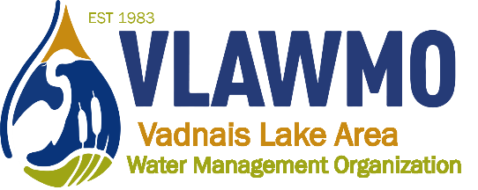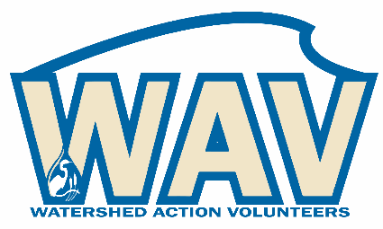
Watershed Action Volunteers
March 7th, 2023
6:00-7:30 pm
Online meeting:
Join Zoom Meeting: https://us02web.zoom.us/j/81169611007
Meeting ID: 811 6961 1007 One tap mobile +16469313860,,81169611007#

Agenda:
1. Introductions

2. 2023 opportunities
- “Soil your Undies” education activity
- Birch Lake Elementary + Rotary Park partnership
- VLAWMO 40-year anniversary
- Neighborhood tours
- L2L + consultation chats
- 2023 game plan spreadsheet

3. Website renovation: Preview and direction

4. 2023 volunteer application forms

5. Closing questions and discussion

