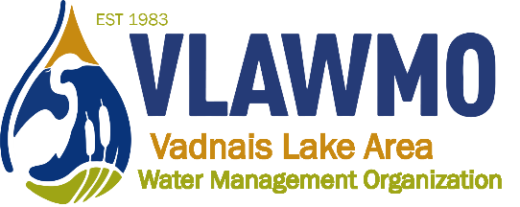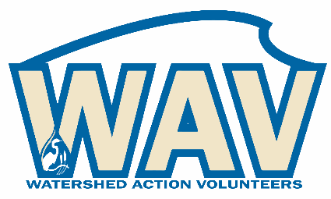

Watershed Action Volunteers
March 17th, 2021
5:30-7pm
Online meeting:
Join Zoom Meeting: https://us02web.zoom.us/j/83426870822
Meeting ID: 834 2687 0822 One tap mobile +13126266799, 83426870822# US (Chicago)

Agenda:
1. Introductions

2. Minnesota Water Stewards Capstone Projects
Project potentials
Graduated Steward team-up and assistance

3. 2021 Programs:
Preview of White Bear Center for the Arts programming
Continued from 2020: Rainbarrel
2021 standard and feasible programs:
Native plant swap, neighborhood tour, Jr Watershed Explorer, fieldwork volunteer days, Leaf Pack macroinvertebrates, picture posts
2021 wish list:
Public and school raingarden brush-ups, AIS detection, Birch Lake sand-iron filter, Adopt-a-Drain promo in East Goose subwatershed, MS4 strategies (salt, pet waste, illicit discharge, adopt-a-drain, BMP’s), and watershed “culture crafter”/demonstration of water-friendly behaviors

4. Other ideas, recap, and questions

5. Advising:
Feedback for WAV webpage, documents, VLAWMO operations, and Nick

