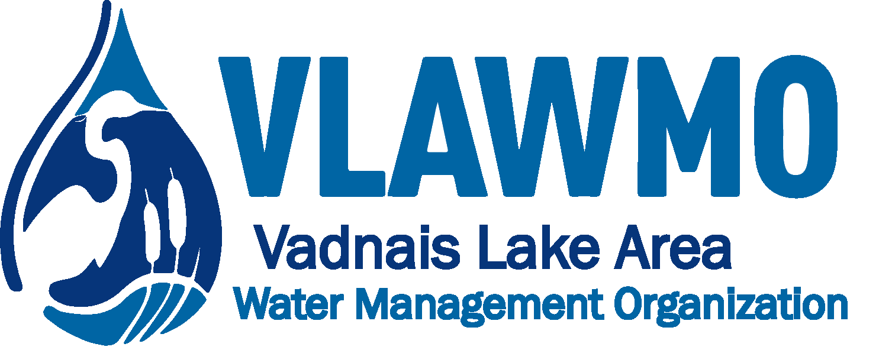
BlueThumb + VLAWMO Workshops 2023
Social Media Post Language
Turf Alternatives:
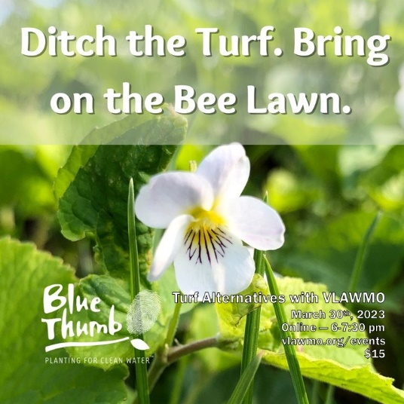

What does it take to convert a traditional turfgrass lawn into a flowering pollinator lawn? Learn how in our upcoming Turf Alternatives workshop with Blue Thumb! 🌱🐝

Join BlueThumb and VLAWMO on March 30th to hear from expert presenters about how you can adopt turf alternatives that promote pollinator health, water quality, and natural resource conservation.

In addition to a virtual presentation and Q&A session with an expert, you'll gain access to online learning modules with videos and downloadables to assist you on your project.

All participants can choose to automatically enter our Lawns to Legumes lottery to receive a $350 cost share grant for creating pollinator habitat, supported by the Minnesota Board of Water and Soil Resources.

Get details and register on the Blue Thumb website: https://bluethumb.org/events/ or vlawmo.org/events

Resilient Yards:
Make your yard more resilient with Blue Thumb's Resilient Yards workshop! 🌿

Join BlueThumb and VLAWMO for a virtual session on April 18th with expert landscape designers. You'll gain the DIY skills you need to:

🌼 Beautify your landscape
🐝 Create habitat for pollinators
💧 Make your yard ready to take on excessive heat, flooding rains, and other weather-related challenges

All participants receive access to Blue Thumb’s free Resilient Yards online learning series and can choose to automatically enter our Lawns to Legumes lottery to receive a $350 cost share grant for creating pollinator habitat, supported by the Minnesota Board of Water and Soil Resources.

Learn more and sign up on the Blue Thumb website: https://bluethumb.org/events/ or vlawmo.org/events

