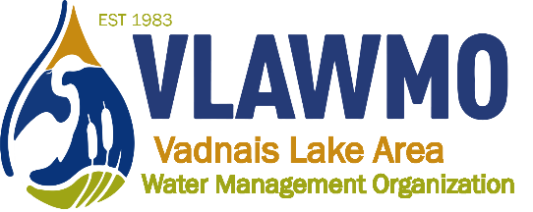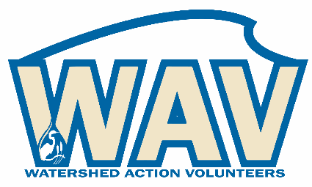
Watershed Action Volunteers
March 17th, 2022
6:00-7:30 pm
Online meeting:
Join Zoom Meeting: https://us02web.zoom.us/j/83784935254
Meeting ID: 837 8493 5254 One tap mobile +1 312 626 6799 US (Chicago)

Draft agenda:
1. Introductions
2. Good Neighbor Guide
- Team of editors and collaborators
- Identify specialty sections
3. 2022 opportunities:
- WAV Activities and Sign-up Sheet – Google sheets access
Link to spreadsheet
4. Collaboration efforts:
- Teal Pond at Tamarack Nature Center
    - Pilot WHEP program (Wetland Health Evaluation Program)
- Bridgewood raingarden in Vadnais Heights
    - Communications and activity campaign
    - CAC input, Master Gardeners partnership, new adopt-a-raingarden site, City communications connecting Bridgewood raingarden to large-scale watershed efforts
- WB Montessori: August 11th on-site walking plant tour led by VLAWMO and Natural Shores Technology
- North Oaks Bioswale: Follow-up maintenance with MN Water Stewards, NOHOA. Development of Maintenance Guide
- Raingarden maintenance and tours: 3 part series with Rice Creek and Ramsey Washington watersheds
    - June 9th: Lake Josephine
    - July 21st: Lakeaires Elementary
    - Sept 22nd: WBL neighborhood curb-cuts
5. CAC advising:
Feedback potentials:
- WAV webpage
- VLAWMO website update
- VLAWMO operations
- WAV shirts?

