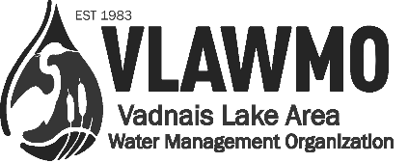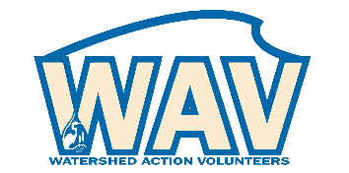
Watershed Action Volunteer Application 2024
For coordinated volunteer roles with the Vadnais Lake Area Water Management Organization (VLAWMO), please tell us about yourself, your interests, your skills, and the role that you’d like to fulfill.
The information on this form will be kept confidential and will help us find the most satisfying and appropriate volunteer opportunity for you. Thank you for your interest in supporting water resources.
Completed applications should be sent to wav@vlawmo.org.

Name: _______________________________________________________________________________
Address: ______________________________________________City: ___________________________
State:_ _______ Zip: __________ Phone: ___________________________________________________
Email:___________________________________ School/Employer: ____________________________
1. Select volunteer area of focus desired:

___ Education and Demonstration
Education campaigns, environmental behaviors demonstration, door hangers and similar outreach, workshop coordination, BMP consultations (bee lawns, raingardens, etc.)
___ Partners and Collaboration
Project kick-off and open house events, local tours, tabling and dispersing education materials at public events, photo gallery display, special school and community group efforts and planning, end-of-year volunteer banquet

___ Fieldwork
Macroinvertebrate monitoring, aquatic invasive species (AIS) monitoring, adopt-a-raingarden, raingarden renovation, photography

___ Citizen Advisory and Other
Advising and input on Website, communications, and operations, etc.

Sub-topic(s) and activities from the above selected categories that are of interest:
See the 2023 Watershed Action Volunteers Google Spreadsheet or contact staff to request access

2. Background:

Past volunteer experience:

What talents or skills do you bring that you feel would benefit our organization?

3. Customizations and special needs:
In the open space below, describe how your desired area of interest can be customized to meet your needs and interests. VLAWMO will work with you to outline a meaningful, practical volunteer experience.
What position customizations are needed to support you for a successful volunteer experience?

Do you have any special needs or accommodations you’d like VLAWMO to know about?

4. Availability:
Please indicate days you’re most available (circle or highlight): Mon Tues Wed Thur Fri Sat
Month (start/end):
Year(s):
Times available: From ______ to _________ Any physical limitations? _____________________
Annual hours willing to dedicate to volunteer role: _________________________

5. Personal Reference:

Name:_______________________ __________________Phone: ________________________________
Relation: _______________________________________

6. Emergency Contact:
In case of emergency contact: ______________________ Phone: _______________________________
Relation: _______________________________________

7. Volunteer Agreement:
As a volunteer I agree to abide by the guidelines and recommendations from VLAWMO staff when engaging with the public. I understand that I will be volunteering at my own risk and that the VLAWMO, its employees and affiliates, cannot assume any responsibility for any liability for any accident, injury or health problem which may arise from any volunteer work I perform for the organization. I agree that all the work I do is on a volunteer basis and I am not eligible to receive any monetary payment or reward.

Signature: _______________________________________________________________________
Date: __________________________

